SQLite primer: Answer sheet

Exercise 1
Write an SQL query that returns the patient_id, first_name, surname and date_of_admission for all patients admitted on or after 1st January 2026. Order the results by admission date, with the most recently admitted patients first.
Answer:
SELECT
patient_id,
first_name,
surname,
date_of_admission
FROM patient_data
WHERE date_of_admission >= '2026-01-01'
ORDER BY date_of_admission DESC;

Exercise 2
Write a query to identify patients who have both:
- A systolic blood pressure (sys_bp) of 140 mmHg or higher.
- A heart rate (heart_rate) greater than 100 beats per minute.
Return patient_id, sys_bp, dia_bp and heart_rate. Order the results by systolic blood pressure, highest first.
Answer:
SELECT
patient_id,
sys_bp,
dia_bp,
heart_rate
FROM admission_observations
WHERE sys_bp >= 140
AND heart_rate > 100
ORDER BY sys_bp DESC;

Exercise 3
Using the medications table, write a query to determine how many times each drug has been prescribed. Your query should:
- Return the drug name and number of prescriptions.
- Use the alias prescription_count for the calculated column.
- Order the results from the most frequently prescribed drug to the least.
Answer:

SELECT
prescribed_drug_name,
COUNT(*) AS prescription_count
FROM medications
GROUP BY prescribed_drug_name
ORDER BY prescription_count DESC;

Exercise 4
The patient_data table contains demographic information, while the medications table contains prescribed drugs. Write a query that returns the following information for patients prescribed Amlodipine:
- Patient ID
- First name and surname
- Date of birth
- Prescribed drug name
- Dose, units and frequency
Order the results alphabetically by surname.
Answer:

SELECT
p.patient_id,
p.first_name,
p.surname,
p.dob,
m.prescribed_drug_name,
m.dose,
m.units,
m.frequency
FROM patient_data AS p
JOIN medications AS m
ON p.patient_id = m.patient_id
WHERE m.prescribed_drug_name = 'Amlodipine'
ORDER BY p.surname ASC;

Exercise 5
A researcher wants to investigate the medications prescribed to patients with elevated systolic blood pressure. Write an SQL query that combines information from all three tables (patient_data, admission_observations and medications).
Your query should:
- Return the patient's ID, first name and surname.
- Include their systolic and diastolic blood pressure.
- Include their prescribed medication name, dose and frequency.
- Include only patients with a systolic blood pressure of 160 mmHg or higher.
- Add a computed column called bp_category using CASE, classifying systolic BP as:
  - 160–179: Grade 2 Hypertension
  - 180 or higher: Grade 3 / Severe Hypertension
- Order the results by systolic blood pressure, highest first.
Answer:
SELECT
p.patient_id,
p.first_name,
p.surname,
o.sys_bp,
o.dia_bp,
m.prescribed_drug_name,
m.dose,
m.frequency,
CASE
WHEN o.sys_bp < 180
THEN 'Grade 2 Hypertension'
ELSE 'Grade 3 / Severe Hypertension'
END AS bp_category
FROM patient_data AS p
JOIN admission_observations AS o
ON p.patient_id = o.patient_id
JOIN medications AS m
ON p.patient_id = m.patient_id
WHERE o.sys_bp >= 160
ORDER BY o.sys_bp DESC;

Exercise 6
Using the database schema (click database structure) and the https://dbdiagram.io/d tool (which uses DBML (Database Markup Language)), create a data model (entity relationship model) of the database showing the three tables and the relationships between them.

Answer:

Table patient_data {
patient_id integer [pk]
first_name varchar [not null]
surname varchar [not null]
dob date [not null]
address1 varchar [not null]
address2 varchar
post_code varchar [not null]
next_of_kin_name varchar
next_of_kin_contact varchar
date_of_admission date [not null]
}

Table admission_observations {
observation_id integer [pk]
patient_id integer [not null, unique]
sys_bp integer [not null]
dia_bp integer [not null]
heart_rate integer [not null]
spo2 integer [not null]
respiratory_rate integer [not null]
temp_c decimal [not null]
ews integer [not null]
}

Table medications {
medication_id integer [pk]
patient_id integer [not null]
prescribed_drug_name varchar [not null]
strength varchar [not null]
dose decimal [not null]
units varchar [not null]
frequency varchar [not null]
route varchar [not null]
}

// One-to-one relationship
Ref: patient_data.patient_id - admission_observations.patient_id

// One-to-many relationship
Ref: patient_data.patient_id < medications.patient_id

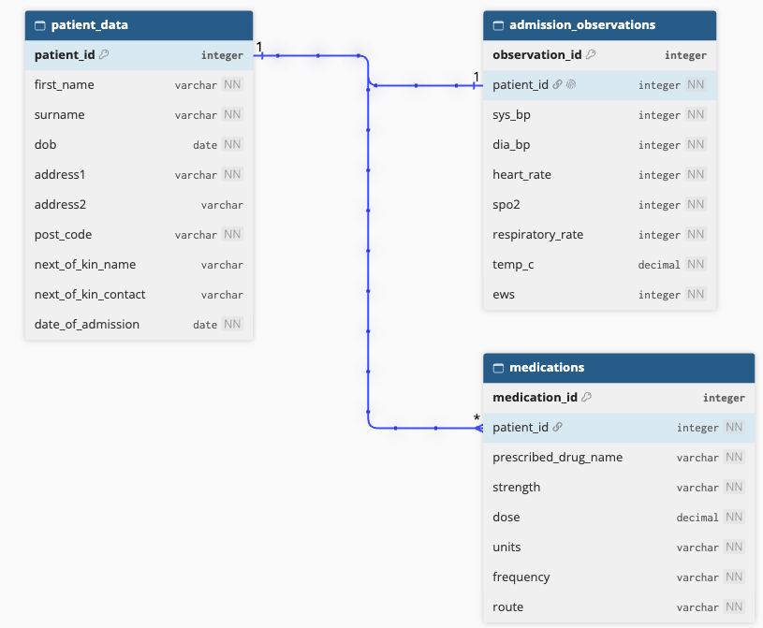

Exercise 7
Write an SQL query that returns all medications whose prescribed drug name contains the text morph, regardless of where it appears in the name. Return the medication_id, patient_id, prescribed_drug_name, strength and dose.
Answer:
SELECT
medication_id,
patient_id,
prescribed_drug_name,
strength,
dose
FROM medications
WHERE prescribed_drug_name LIKE '%morph%';

Exercise 8
Write an SQL query that counts how many patients were admitted in each calendar year. Your query should return the admission year and the number of patients admitted in that year, ordered from the most recent year to the earliest.

Answer:

SELECT
strftime('%Y', date_of_admission) AS admission_year,
COUNT(*) AS patient_count
FROM patient_data
GROUP BY strftime('%Y', date_of_admission)
ORDER BY admission_year DESC;

Exercise 9
Write an SQL query that calculates the average prescribed dose for each medication. Return the drug name, dose units and average dose, rounded to two decimal places. Only include medications that have been prescribed at least three times. Order the results by average dose, highest first.

Answer:

SELECT
prescribed_drug_name,
units,
ROUND(AVG(dose), 2) AS average_dose,
COUNT(*) AS prescription_count
FROM medications
GROUP BY prescribed_drug_name, units
HAVING COUNT(*) >= 3
ORDER BY average_dose DESC;

Exercise 10
A researcher wants to investigate prescribing patterns for drugs containing the text ‘pril’ (for example, ramipril or lisinopril).
Write an SQL query that:
- Identifies medications whose names contain ‘pril’.
- Joins the medications and admission_observations tables using patient_id.
- Groups the results by prescribed drug name.
- Returns the drug name, number of prescriptions and average systolic blood pressure.
- Rounds the average systolic blood pressure to one decimal place.
- Orders the results by prescription count, highest first.
Answer:

SELECT
m.prescribed_drug_name,
COUNT(*) AS prescription_count,
ROUND(AVG(o.sys_bp), 1) AS average_sys_bp
FROM medications AS m
JOIN admission_observations AS o
ON m.patient_id = o.patient_id
WHERE m.prescribed_drug_name LIKE '%pril%'
GROUP BY m.prescribed_drug_name
ORDER BY prescription_count DESC;

